**May 2014 SL P1**

**Section A**

1. Identify **two** features that need to be considered when planning a new computing system for

an organization. [2]

Roles/activities of the users (*eg* permissions, security, partitions, collaborative work);

Resources (HW and SW equipment) appropriate for the organization;

Costs/budget limits;

Delivery time;

Compatibility with the old system (data);

*(Other acceptable answers are possible, from the economic, operational and technical*

*perspective.)*

1. Explain what is meant by beta testing. [2]

Testing prior to product’s full release / last stage of testing;

To see if it works properly / complete functionality / usability;

Performed by end users (not by designers);

1. Describe **one** advantage and **one** disadvantage of using observations to gather information

when planning a new system. [4]

*Award* ***[1 mark]*** *for the identification of an advantage and* ***[1 mark]*** *for explaining the*

*advantage.*

*Award* ***[1 mark]*** *for the identification of a disadvantage and* ***[1 mark]*** *for explaining the disadvantage.*

*Advantages*

*Quick/first hand/realistic information on data/software/hardware/users/procedures in the current system.  
Help better understand positive and negative features of the current system (for example problems in accessing or validating data/user errors/security issues, etc.).  
Can highlight aspects that are not detected in questionnaires/interviews so the observer can help produce more detailed reports.*

*Disadvantages*

*Time consuming / expense.  
The observer might need to observe a complete "cycle" which could last a significant  
amount of time.  
If the observations are made by only one person, they may be biased.*

1. Outline **one** usability issue associated with the design of mobile devices. [2]

*Award* ***[1 mark]*** *for identifying an issue and* ***[1 mark]*** *for an explanation.*

Size of screen;

Therefore difficult to see / use (in poor light);

Size of keys;

Therefore difficult to access functions;

Battery life;

May need to recharge regularly;

Touch screen keys on tablets *etc*;

Lack of tactile feedback;

1. Distinguish between the use of **two** types of primary memory. [2]

*Award up to* ***[2 marks max]****.*

*Award* ***[1 mark]*** *for identifying* ***two*** *types of primary memory.*

*Award* ***[1 mark]*** *for the use of* ***each*** *type of the memory identified ×2.*

RAM stores data and instructions currently in use

ROM stores permanent instructions

Cache stores frequently used instructions

*(Award* ***[1 mark]*** *if only general scheme of CPU is given.)*

1. Outline, with an example, one benefit of using computer-aided design (CAD) applications. [2]

*Award* ***[1 mark]*** *for an example and* ***[1 mark]*** *for reason of use/functionality, up to*

***[2 marks max]****.*

Support design/layout/development/rapid prototyping in engineering/manufacturing

/biomechanics/architecture;

Save time/costs associated to drawing/development;

Photorealistic rendering/photo simulation in architecture/video games/visual

effects/simulators;

*eg* shading, radiosity, reflection, refraction, illumination for modelling and simulation;

1. Outline how a colour can be represented in a computer. [2]

A colour will be split into three components *(Accept RGB as an example)*;

Each component will be assigned a certain number of bytes;

1. Identify **two** key features of a peer-to-peer (P2P) network. [2]

*Award up to* ***[2 marks max]***.

*Examples of features:*

No central server;

Resources are more widely available (storage, bandwidth, computing power);

Redundancy/recovery;

Supports file sharing for collaborative work;

1. Define the term data packet. [2]

unit of data for transmission;

With a format;

*Accept answers that expresses the idea that the packet is the fundamental unit of data*

*transmission on a network (IP is assumed).*

*Accept answers that suggest the student understands there is a format for the packet,*

*including “contains address and data”.*

1. Explain why the speed of data transmission across a network can vary. [3]

*Award up to* ***[2 marks max]*** *for identifying causes of speed differences*.

Different parts of network use different media;

Network congestion;

Packets may take different routes;

The receiver may be busy;

Physical size of the network;

*Award the final* ***[1 mark]*** *for any explanation of a cause may affect the speed.*

Fiber is faster than coax;

Some packets may be delayed by congestion;

There may be longer transmission times over large distances;

1. Explain why an object is an example of abstraction. [2]

*Award up to* ***[2 marks max]***.

An object hides the details;

Yet preserves the functionality;

**OR**

Objects combine abstractions of data and code;

While hiding away implementation of details;

**Section B**

1. Harry is Tired (T) depending on the following three variables:

• Work (W)

• Hunger (H)

• Sun (S).

Harry is tired if:

• he works and he is hungry

• he works and it is not sunny

1. Represent, as a single logical expression, the conditions that cause Harry to be tired. [3]

*(Notation: * is* ***and****, + is* ***or****, – is* ***not)***

*Award* ***[1 mark]*** *for each correct sub-expression in the “+” relation, up to* ***[3 marks max]****.*

W*H + W*-S + -W*-H

Alternative equivalent solution:

W*(H+-S) + -W*-H

1. Construct the truth table to show when Harry is tired. [4]  
     
   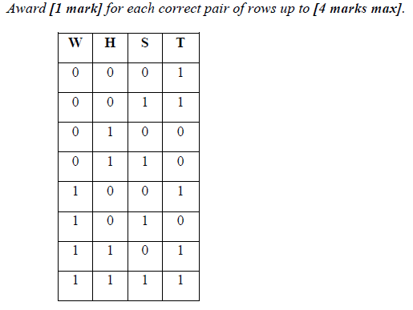

A professor notices that students are generally very tired and decides to investigate the

relationship of tiredness with Work, Hunger and Sun.

Consider the following truth table which shows the conditions for Tired based on Work,

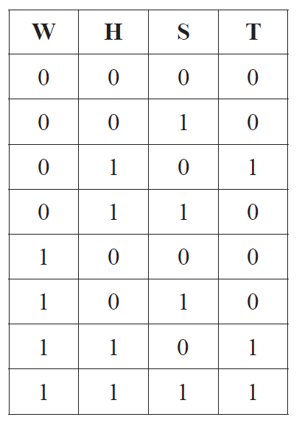Hunger and Sun.

The conditions for one of the students to be tired can be expressed in the following array,  
 TIRED, where the index is equivalent to the combination of W, H and S in the truth table.

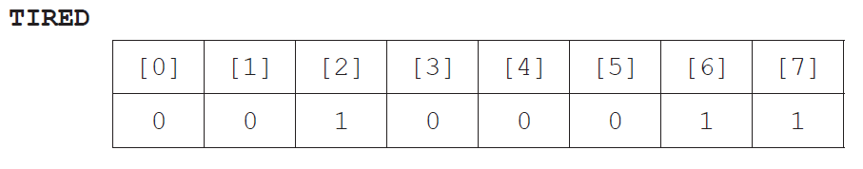

1. Identify a relationship between the value of S and the index of the array TIRED. [1]

Odd index gives S = 1;

1. Construct an algorithm, *TEST*, in pseudocode, to output the conditions *W*, *H* and *S* from

the array *TIRED* for a student who is tired. [4]

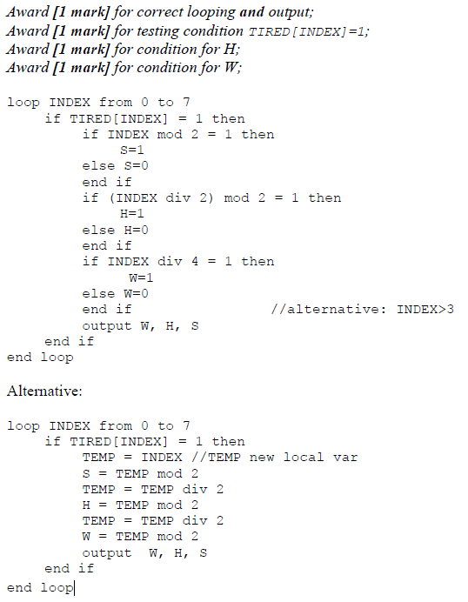

A collection, *STUDENT*, is used to hold the name and the array *TIRED* for each student.

1. Outline the way in which your algorithm could be used to output the names of all those

students who are tired due to *Work* **and** *Hunger*. [3]

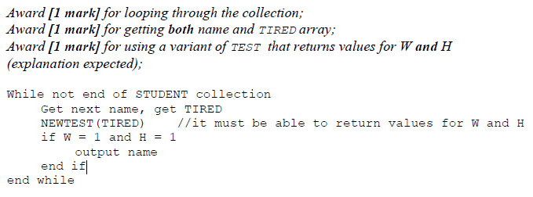

*Accept answers not pseudocode, for example:*

For each element in the collection STUDENT;

Retrieve **both** Names and Tired;

Use a variant of TEST(TIRED) and **returns** values for W **and** H to output the

corresponding name when both are 1;

1. An international organization has offices located across several countries. For some of

its activities, for example human resource management, it has been decided to adopt a

“Software-as-a-Service” (SaaS) solution in order to keep the running costs low.

1. Describe the features of SaaS. [3]

Data is in the cloud/computing infrastructure;

SW necessary for the activities is in the cloud;

Access to SW is with thin client (terminal/computers) by web browsing (on the

extranet);

1. Discuss the limitations of SaaS in relation to security. [6]

*Award up to* ***[6 marks max]****.*

Security in storage;

Data is stored in the server of the service provider;

The organization has no direct control of its data;

Legislation in the country of the provider may be weaker than in the user’s

country;

Cases of provider’s corruption/bankruptcy/data loss are a risk to the

organization;

Security in transmission;

Applications running in-site may require data in SaaS;

Hence longer transmission times and higher risk of failure

/attack/interception;

Each office makes some data available to external customers through the use of an extranet

and allows employees to work from home through a VPN.

1. Define the term extranet. [2]

An external extension to a company’s local network;

Limited access;

Uses internet protocols;

1. Distinguish between a VPN and an extranet. [4]

VPN authenticates the sender before (establishing the tunnel);

VPN access is always encrypted, whereas extranet has limited encryption;

VPN transmission is always encrypted;

VPN users have access to everything whereas extranet users only have access to

(enabled) specific services;

1. The faceplate of a car stereo has six buttons for selecting one of six preferred radio stations.

As part of the internal representation of a microprocessor there is an array with six positions,

carrying the information about the radio frequencies, as follows.

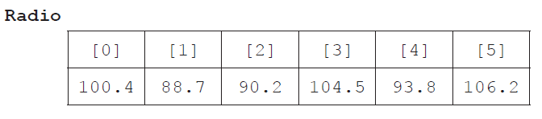

1. State the information at Radio[2]. [1]

90.2;

1. Outline how a numerical frequency could be stored in a fixed-length string. [2]

Frequencies less than 100 take a 0 on the left (*eg* 88.7 becomes 088.7);

Convert each digit into a char to get a string;

*Allow the “dot” to be omitted in the interpretation. There is always only one*

*decimal in the example.*

1. Construct an algorithm in pseudocode that calculates the range of frequencies

(ie the difference between the highest and lowest frequencies) of any set of six selected

radio stations. [6]

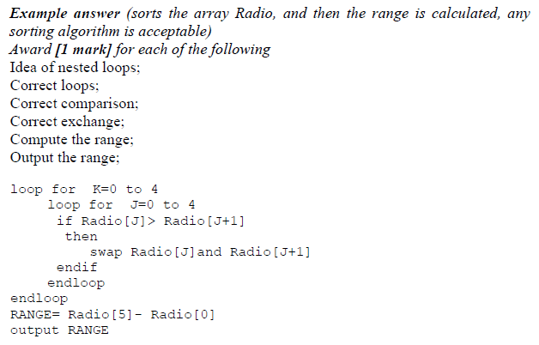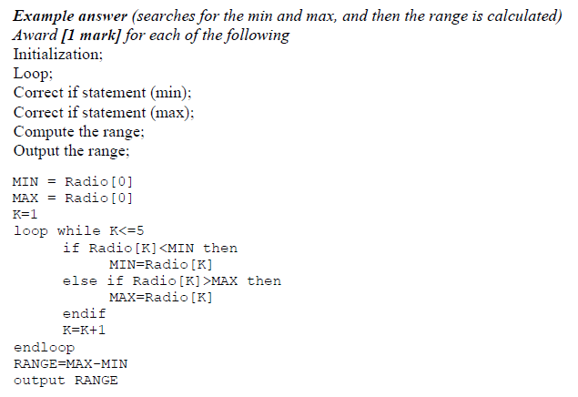

A display in the faceplate shows the name and frequency of the selected radio station. The name  
 is automatically captured when storing a preference.

1. Outline how a collection of objects could be used to store the name and frequency data in

the radio. [2]

Upon selection, two new objects are created in the collection one with the name,

the other with the frequency / Upon selection, a new object is created containing

both name and frequency;

Where the name is obtained from the radio station;

1. Construct an algorithm, in pseudocode, to access and display the name and frequency of

a station when a button is pressed. [4]

